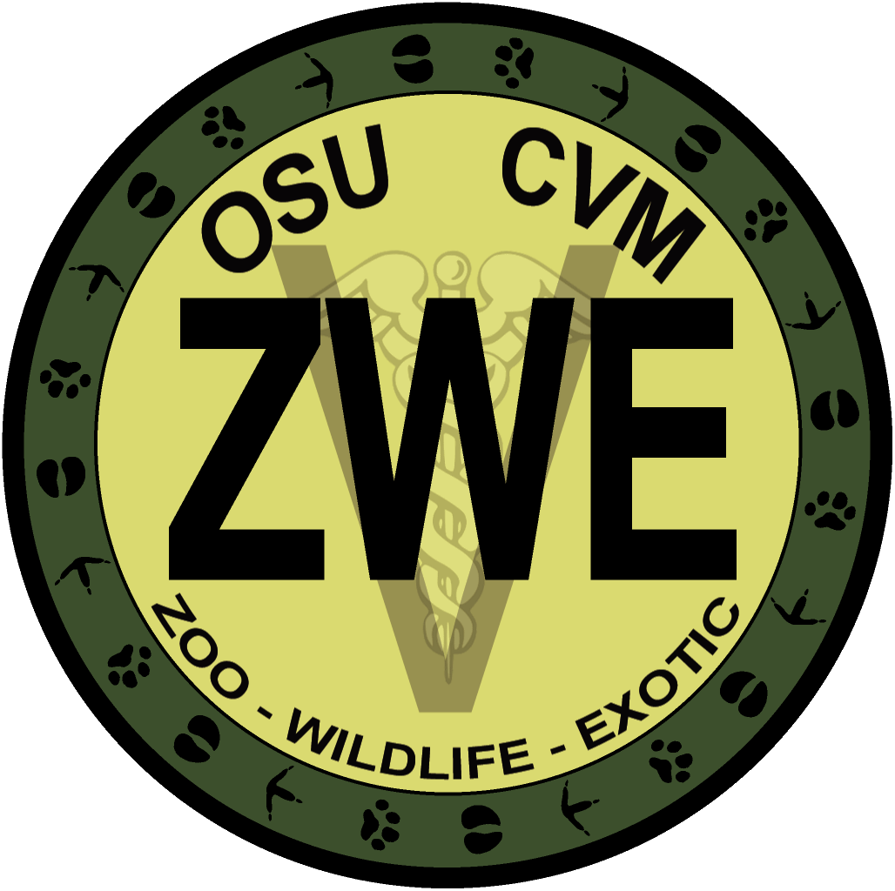
1st Annual WDA and ZWE Symposium
October 16-17, 2010
Corvallis, OR

Mail in registration must be received by October 8th, 2010. An email confirmation will be sent upon receiving your registration. If you do not receive this confirmation, please contact us.
Title (circle one): Dr. Mr. Mrs. Ms. Miss
Name (First, Last): .
Street Address: .
City/State/Zip: .
E-mail: ,
Organization/Affiliation: .

Registration for Saturday, October 16
. STUDENT - $18 (includes lunch)
. NON-STUDENT - $36 (includes lunch)
. WETLAB – $8
Lunch (please circle one): Vegetarian Non-vegetarian

Registration for Sunday, October 17
. STUDENT - $9
. NON-STUDENT - $18

. Copy of conference proceedings will be available for $7. A CD of proceedings will be provided at no extra cost to symposium attendees.
Mail completed form with check payable to OSU ZWE to:
Attn: WDA/ZWE Club
OSU Veterinary Medicine
105 Magruder Hall
Corvallis, OR 97331
Mail in registration must be received by October 8th. You will be allowed to register on the day of the symposium but prices will increase by $5 and lunch may not be available.

